**How to JavaScript: Assignment 1**

**Name: Aman**

Complete the following assignments. All the outputs should be printed in console only

**A whatsApp group will be shared to submit your assignments**

**Assignment 1: Array Operations**

Objective: Practice adding, removing, and updating values in arrays.

1. Create an empty array called "fruits".

**Ans:**

let fruits = [];

console.log(fruits);

**Output:**

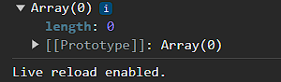

2. Add the following fruits to the "fruits" array: "apple", "mango", "orange".

**Ans:**

let fruits =['apple','mango','orange'];

console.log(fruits);

**Output:**

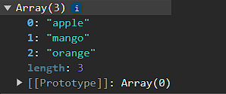

3. Remove the first fruit from the array.

**Ans:**

let fruits =['apple','mango','orange'];

fruits.splice(0,1)

console.log(fruits);

**Output:**

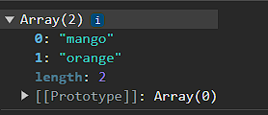

4. Add "grape" to the end of the array.

**Ans:**

let fruits =['apple','mango','orange'];

fruits.push('grape');

console.log(fruits);

**Output:**

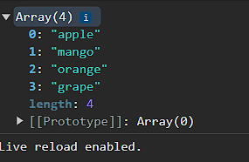

5. Update the second fruit in the array to "pear".

**Ans:** let fruits =['apple','mango','orange',];

fruits.push('grape');

fruits[1]='pear'

console.log(fruits);

**Output:**

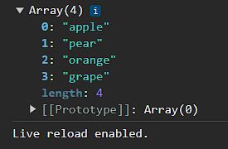

6. Print the final "fruits" array after performing the above operations.

**Ans:**

let fruits =['apple','mango','orange'];

fruits.push('grape');

fruits[1]='pear'

console.log(fruits);

**Output:**



**Assignment 2: Object Operations**

Objective: Practice adding, removing, and updating values in objects.

1. Create an empty object called "person".

**Ans:**

let person ={

};

console.log(person)

**Output:**

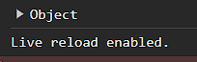

2. Add the following properties to the "person" object:

- name: "John"

- age: 30

- city: "New York"

**Ans:**

let person = {

    name: 'john',

    age: 30,

    city: 'New York'

};

console.log(person)

**Output:**

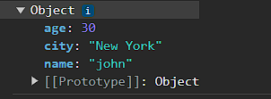

3. Remove the "age" property from the "person" object.

**Ans:**

let person = {

    name: 'john',

    age: 30,

    city: 'New York'

};

delete person['age']

console.log(person)

**Output:**

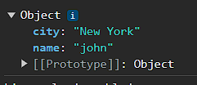

4. Add a new property called "job" with the value "Engineer" to the "person" object.

**Ans:**

let person = {

    name: 'john',

    age: 30,

    city: 'New York'

};

delete person['age']

person.job='engineer'

console.log(person)

**Output:**

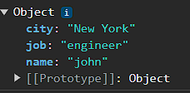

5. Update the "city" property of the "person" object to "San Francisco".

**Ans:**

let person = {

    name: 'john',

    age: 30,

    city: 'New York'

};

delete person['age']

person.job ='engineer'

person.city ='San Francisco'

console.log(person)

**Output:**

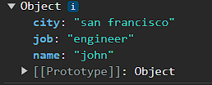

6. Print the final "person" object after performing the above operations.

**Ans:**

let person = {

    name: 'john',

    age: 30,

    city: 'New York'

};

delete person['age']

person.job ='engineer'

person.city ='San Francisco'

console.log(person)

**Output:**



**Assignment 3: Array of Objects Operations**

Objective: Practice adding, removing, and updating values in an array of objects.

1. Create an empty array called "cars".

**Ans:**

let cars = [

]

console.log(cars)

**Output:**

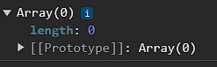

2. Add three car objects to the "cars" array. Each car object should have the following properties:

- make: "Toyota"

- model: "Camry"

- year: 2018

**Ans:**

let cars = [];

cars.splice(0, 0, { make: 'Maruti Suzuki', model: 'swift', year: 1998 },

{ make: 'Ford', model: 'endevour', year: 2019 },

 { make: 'Hyundai', model: 'Alcazer', year: 2020 })

console.log(cars)

**Output:**

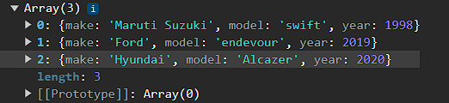

3. Remove the first car object from the "cars" array.

**Ans:** let cars = [

]

cars.splice(0, 0, { make: 'Maruti Suzuki', model: 'swift', year: 1998 },

{ make: 'Ford', model: 'endevour', year: 2019 },

 { make: 'Hyundai', model: 'Alcazer', year: 2020 })

 cars.pop(cars[3[0]]);

console.log(cars)

**Output:**

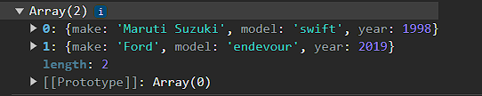

4. Add a new car object to the "cars" array with the following properties:

- make: "Honda"

- model: "Civic"

- year: 2020

**Ans:**

let cars = [

    { make: 'toyota', model: 'camry', year: 2018 }

]

cars.push({make: "Honda", model: "Civic", year: 2020})

console.log(cars)

**Output:**

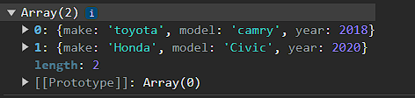

5. Update the "model" property of the second car object in the array to "Accord".

**Ans:** let cars = [

    { make: 'toyota', model: 'endevour', year: 2018 }

]

cars.push({make: "Honda", model: "accord", year: 2020})

console.log(cars)

**Output:**

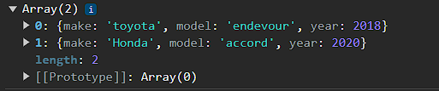

6. Print the final "cars" array after performing the above operations.

**Ans:** let cars = [

    { make: 'toyota', model: 'endevour', year: 2018 }

]

cars.push({make: "Honda", model: "accord", year: 2020})

console.log(cars)

**Output:**



Remember to use console.log() to print the arrays and objects in the console to see the results of each operation.